3 a.Create a prototype with familiar and unfamiliar navigation elements. Evaluate ease of use with different user groups using proto.io

🎯 AIM
To design a prototype with familiar and unfamiliar navigation elements and evaluate usability using Proto.io.
🔹 STEP 1: CREATE PROJECT :
- Go to Proto.io
- Click Create New Project
- Name: “Wonders Navigation Prototype”
- Device: Mobile (iPhone X)
- Click Create
🔹 STEP 2: CREATE SCREENS :
Create 4 main screens:
- Colosseum Screen
- Christ the Redeemer Screen
- Taj Mahal Screen
- Greece Walls Screen
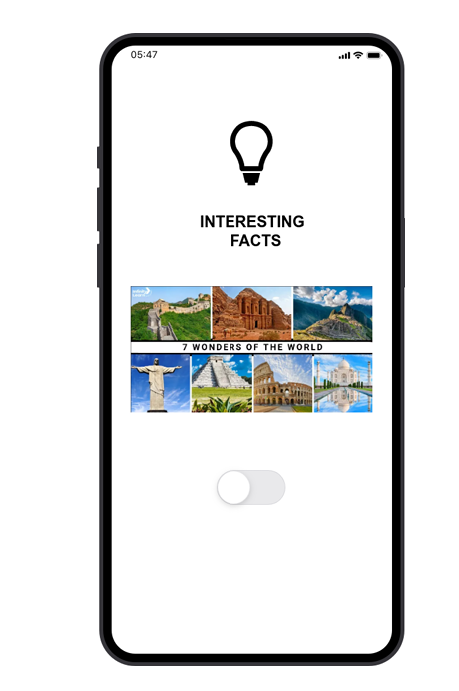
👉 Each screen contains:
- Image (top)
- Title
- Numbered facts
- NEXT button

🔹 STEP 3: ADD FAMILIAR NAVIGATION:
👉 These improve usability (important for evaluation)
1. NEXT Button Navigation
- Add button at bottom: NEXT

Interaction:
- Tap → Navigate to next screen
  - Colosseum → Christ the Redeemer
  - Christ → Taj Mahal
  - Taj Mahal → Greece Walls
2. Back Navigation
- Add ← Back button on top
Interaction:
- Tap → Previous screen
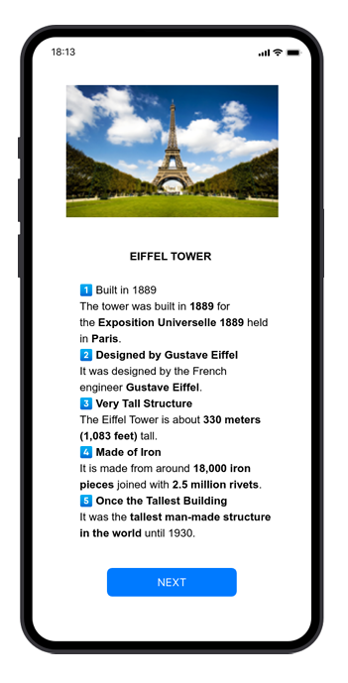
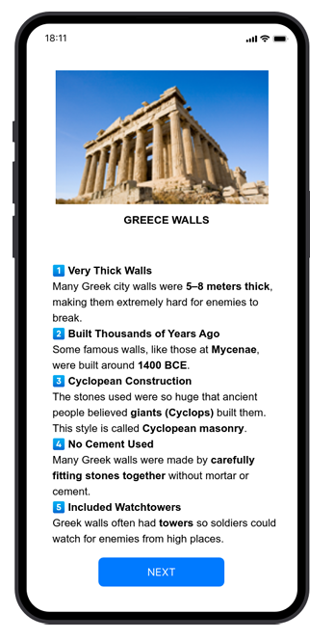
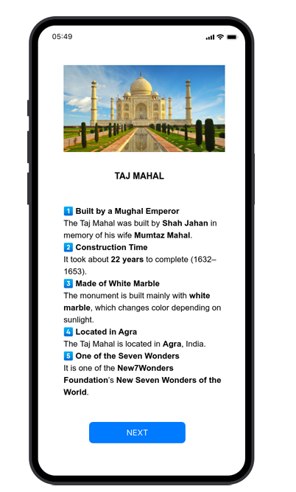
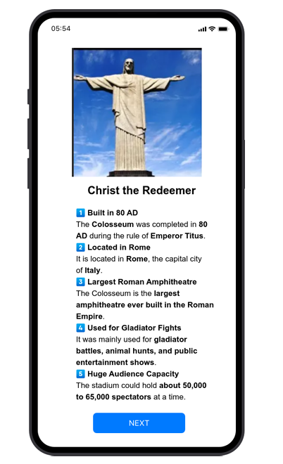
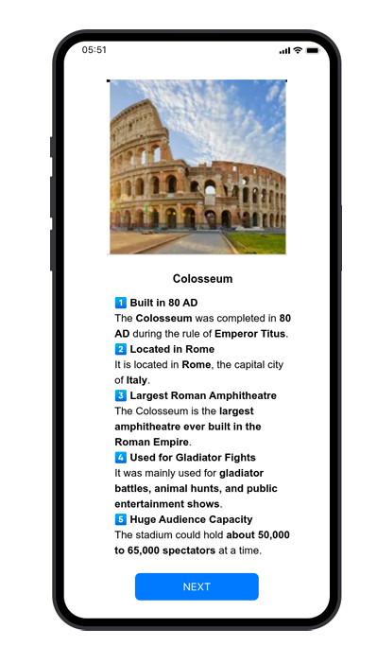
🔹 STEP 4: ADD UNFAMILIAR NAVIGATION
1. Swipe Navigation
- Add gesture:
Interaction:
- Swipe Left → Next screen
- Swipe Right → Previous screen
2. Hidden Gesture Navigation
- No visible button
Interaction:
- Swipe Up → Skip to last screen
- Swipe Down → Go to first screen
3. Image Tap Navigation
- Tap image → Go to next screen
4. Long Press Feature
- Long press on facts → Show popup (extra info)

🔹 STEP 5: ADD INTERACTIONS IN Proto.io
For each screen:
- Select element (button/image)
- Click Interactions
- Add:
  - Tap → Navigate
  - Swipe → Navigate
  - Long press → Popup
🔹 STEP 6: PREVIEW YOUR PROTOTYPE
- Click Preview
- Test:
  - Button navigation
  - Swipe navigation
  - Hidden gestures

🔹 FINAL CONCLUSION
- Familiar navigation improves usability
- Unfamiliar navigation increases creativity but reduces discoverability
- Best design = combination of both

